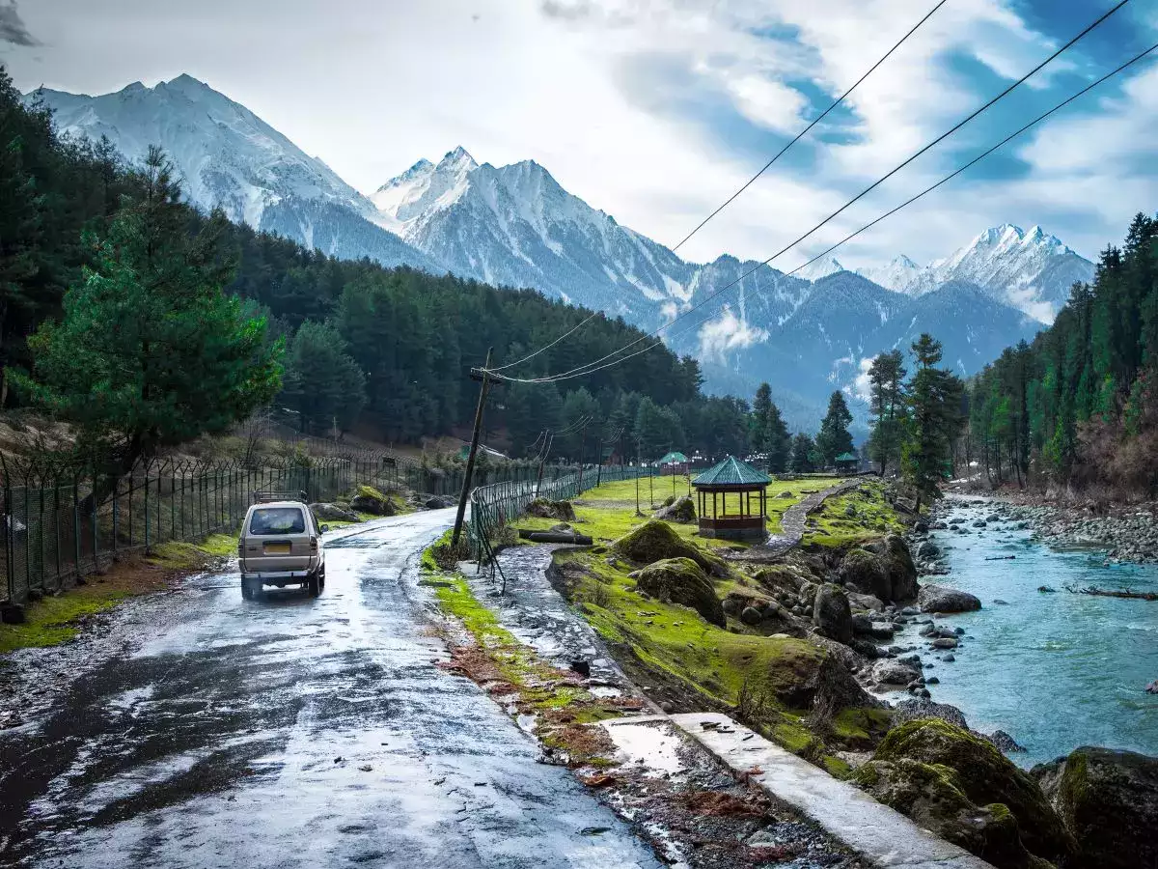

# ***KASHMIR***

NAME : ANKUSH VISHWAKARMA

ROLL NO : 2317062

TOPIC: KASHMIR TOUR ITINEARY

SUB : INDIAN KNOWLEDGE SYSTEM

# INDEX

|  |  |  |
| --- | --- | --- |
| SR.NO | TOPIC | PG.NO |
| 1. | INTODUCTION | 3 |
| 2. | BREIF EXPLANATION ABOUT THE ITINERARY | 4 |
| 3. | DETAILED ITINERARY | 5-8 |
| 4. | INFORMATION ABOUT THE PLACES MENTIONED | 9-24 |
| 5. | CONCLUSION | 25 |
| 6. | REFERENCES | 26 |

# INTRODUCTION OF INDIAN KNOWLEDGE SYSTEM

## WHAT IS INDIAN KNOWLEDGE SYSTEM?

INDIAN KNOWLEDGE SYSTEM(IKS) is an innovative cell under the Ministry of Education (MOE) at AICTE, New Delhi. It is established to promote interdisciplinary research on all aspects of IKS, preserve and disseminate IKS for further research and societal applications.IT will actively engage for spreading the rich heritage of our country and traditional knowledge in the field of Arts and Literature, Agriculture, Basic Science, Engineering& Technology, Architecture, Management, Economics, etc.

## ABOUT INDIAN KHOWLEDGE SYSTEM

The Indian traditional Knowledge Systems (Bhartiya Ganana Parampara) division of ministry education (MoE) located at the headquarter of AICET, Delhi, was established as of October 20 and taken to be a part of the New Education Policy (NEP) starting 2023. e team initially consisted of Shri A.B. Shukla was the Chief Coordinator, followed by the teachers Dr. Sanjeev Panchal, Shri Anurag Deshpande and Shri Shreyas Khurekar. more professors who joined this noble research.

## WHY ARE WE STUDYING IKS?

The main objective of drawing from our past and integrating the Indian Knowledge Systems is to learn that our ancient systems of knowledge represented by an unbroken tradition of knowledge mission and providing a unique perspective (Bhartiya Drishti) is used to solve the current merging challenges of India and the world.

# BRIEF EXPLANATION

Kashmir is a beautiful place in northern India. It's famous for its stunning mountains, lush valleys, and serene lakes. People often visit to enjoy the scenic views, go trekking, or relax on houseboats floating on the Dal Lake in Srinagar. The region has a rich culture and history, with influences from various traditions. However, it has also experienced conflicts over the years. Despite this, Kashmir remains a popular destination for nature lovers and those seeking tranquility

We will go to various places such as:

1. Srinagar

2. Sonmarg

3. Gondola

4. Chandanwari

5. Betaab valley

6. shankarcharya temple

7. Pari mahal

8. Dal lake and various other places

# DETAILED ITINERARY:-

Day 1:

Arrival: Arrive at Srinagar airport around 12:00 PM.

Transfer: Transfer to hotel, estimated arrival at hotel around 1:00 PM.

Afternoon: Rest at the hotel.

Evening: Visit Dal Lake for boating and laser light show (if open), around 4:00 PM.

Night: Stay in Srinagar.

Day 2:

Morning: Breakfast at the hotel around 8:00 AM.

Departure: Depart for Sonmarg around 9:00 AM.

Full Day: Enjoy activities in Sonmarg, arrival around 10:30 AM.

Note: Cost of horse or Sumo vehicle not included in tour cost.

Evening: Return to Srinagar around 6:00 PM.

Night: Stay in Srinagar.

Day 3:

Morning: Breakfast at hotel around 8:00 AM.

Day: Explore local sights in Srinagar including Shankaracharya Temple, Nischat Garden, Chashme Shahi Garden, Botanical Garden, and Pari Mahal, starting at 9:00 AM.

Night: Stay in Srinagar.

Day 4:

Morning: After breakfast, depart for Doodhpatri at 9:00 AM.

Day: Enjoy horse ride and open bus ride, arrival at Doodhpatri around 10:30 AM.

Evening: Return to Srinagar around 5:00 PM.

Night: Stay in Srinagar.

Day 5:

Morning: Breakfast at hotel around 8:00 AM.

Day: Shopping in Srinagar until 11:00 AM, then after lunch, proceed to Gulmarg around 12:30 PM.

Night: Stay in Gulmarg.

Day 6:

Morning: After breakfast, visit Gondola (1st level ticket included) around 9:00 AM.

Afternoon: Proceed to Pahalgam, departure around 12:00 PM.

En route: Visit Bat factory, Kesar farms, and do dry fruit shopping.

Evening: Reach hotel in Pahalgam around 5:00 PM and rest.

Night: Stay in Pahalgam.

Day 7:

Morning: After breakfast, visit Chandanwadi, Betaab Valley, and Aru Valley by union vehicle, departure at 9:00 AM.

Evening: Enjoy DJ and Garba from 6:00 PM onwards.

Night: Stay in Pahalgam.

Day 8:

Morning: After breakfast or lunch (according to flight schedule), depart for Srinagar airport with wonderful memories. Departure time based on flight schedule.

# TOUR CONCLUDES:-

Total tour cost 32000/- per person on twin sharing basis

## INCLUSION:-

1. Twin sharing room.
2. All meals (separate kitchen) & mineral water.
3. Refreshments and foods packets during tour.
4. Private AC bus(2x2) throughout the journey.
5. Games and enjoyment.
6. Entry tickets at all places.

# EXCLUSION:-

1. Any personal expense.
2. Anything not mentioned above.
3. To and FRO flights & train tickets.

# INFORMATION OF THE PLACES MENTIONED:-

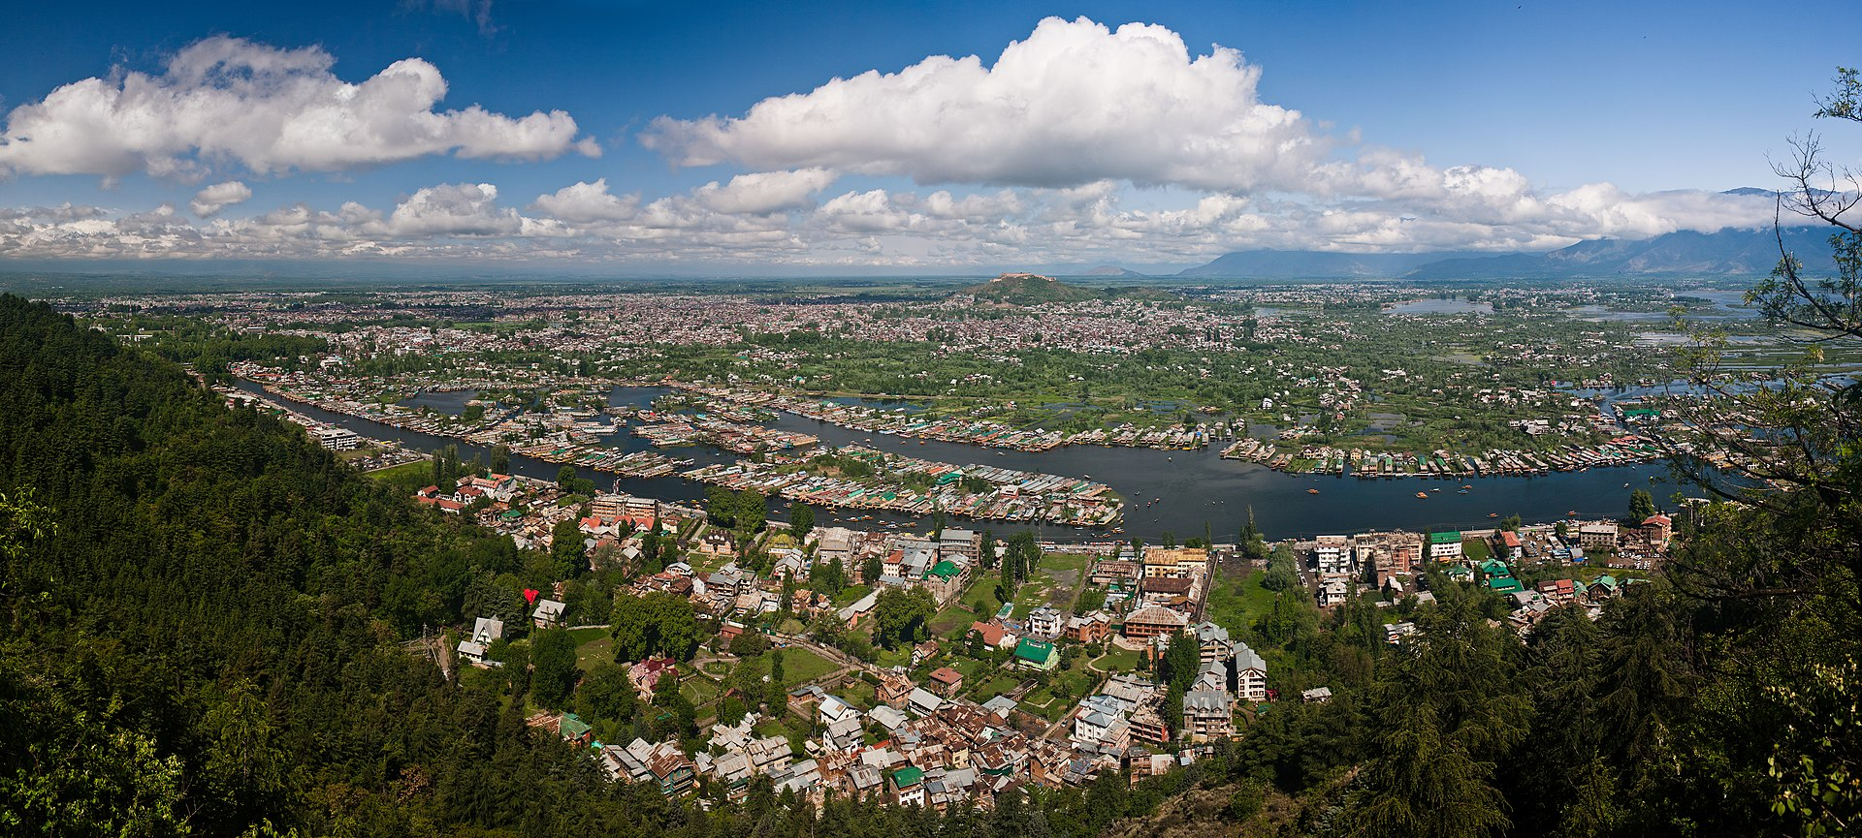SRINAGAR: Srinagar is the largest city and the summer capital of the Indian-administered union territory of Jammu and Kashmir. It is known for its scenic beauty, gardens, houseboats, and the famous Dal Lake. Srinagar has a rich cultural heritage and is a popular tourist destination, especially for its Mughal gardens, such as Shalimar Bagh and Nishat Bagh. The city has faced political unrest and security issues over the years due to the ongoing conflict in the region.

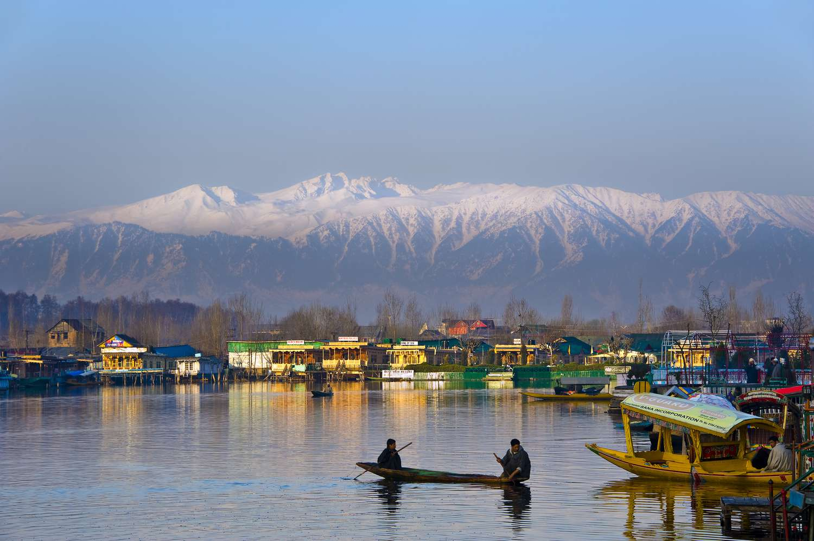Srinagar, in Kashmir, has a long and interesting history. It was founded by King Pravarasena II over 2,000 years ago. Over the centuries, it has been ruled by various dynasties, including the Mauryas, Kushans, and Mughals. Srinagar became a prominent center of Hindu and Buddhist culture and learning during ancient times. In the 14th century, it came under the control of Muslim rulers. The Mughals developed the city further, building beautiful gardens and mosques. In the 19th century, it became part of the Sikh Empire and later the Dogra Kingdom. After India's independence, Srinagar became part of the Indian state of Jammu and Kashmir. Today, it is known for its natural beauty, houseboats, and as a center of the Kashmiri handicraft industry.

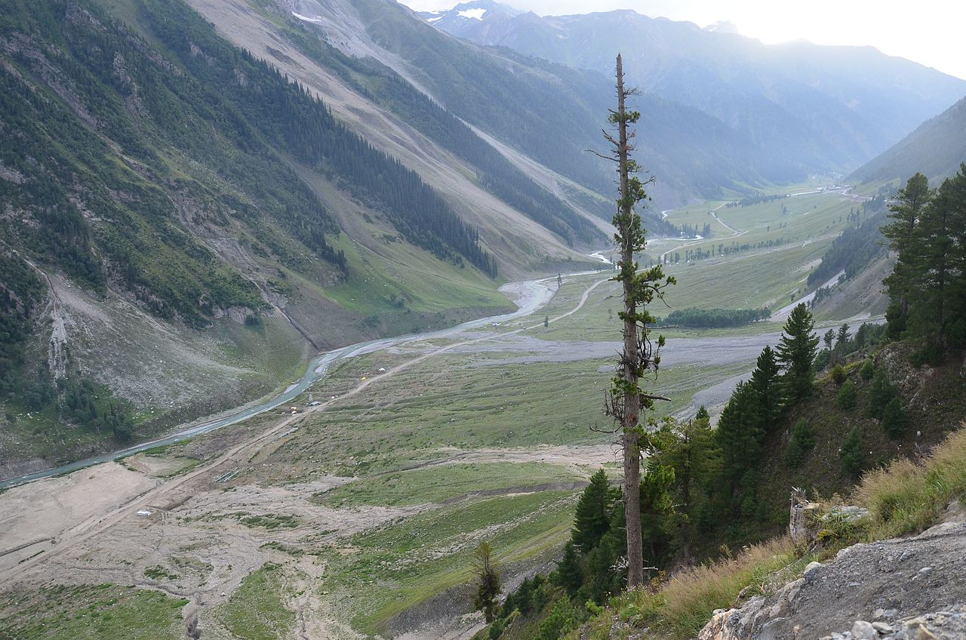SONMARG:

Sonmarg is a beautiful hill station located in the Ganderbal district of Jammu and Kashmir, India. It's known for its picturesque landscapes, serene meadows, and stunning views of snow-capped mountains. Sonmarg, which translates to "Meadow of Gold," is a popular destination for trekking, camping, and adventure sports, especially during the summer months when the weather is pleasant. It's also the base camp for the famous Amarnath Yatra pilgrimage.

Sonmarg, located in the Indian-administered union territory of Jammu and Kashmir, is a beautiful valley surrounded by snow-capped mountains and lush greenery. Its name, Sonmarg, means "Meadow of Gold," possibly derived from the golden hue of the flowers that carpet the valley in the spring.

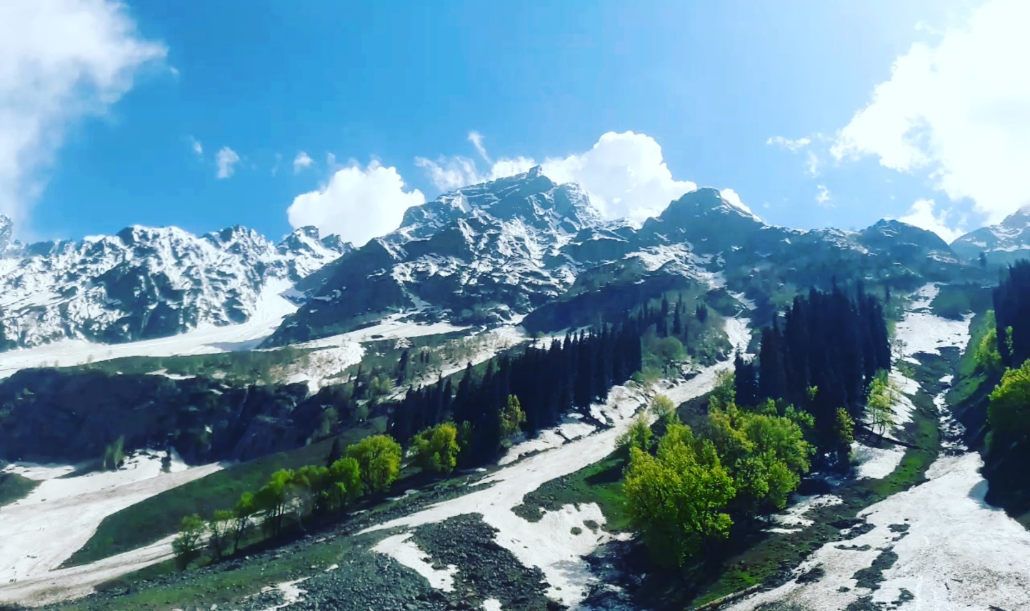

Historically, Sonmarg has been an important stopover on the ancient Silk Road, connecting Kashmir with China and other Central Asian countries. Merchants and travelers traversed through this region, contributing to its cultural exchange and economic significance.

During the colonial era, Sonmarg became a popular summer retreat for British officials seeking respite from the scorching heat of the plains. Its cool climate and stunning landscapes attracted visitors who explored its natural beauty and indulged in recreational activities like trekking and fishing.

In more recent times, Sonmarg has become a popular tourist destination, drawing visitors from all over the world to experience its serene surroundings and adventure opportunities. However, like much of Kashmir, Sonmarg has also been affected by political tensions and occasional conflicts, impacting its tourism industry and the lives of its residents.

Despite these challenges, Sonmarg continues to enchant visitors with its picturesque vistas and cultural richness, making it a cherished destination for nature lovers and adventure enthusiasts alike

GONDOLA:-The Gondola in Kashmir refers to the Gulmarg Gondola, which is one of the highest cable cars in the world. It is located in the town of Gulmarg, in the Indian-administered union territory of Jammu and Kashmir. The Gondola ride offers breathtaking views of the surrounding mountains, valleys, and meadows, making it a popular attraction for tourists visiting Kashmir.

The Gulmarg Gondola operates in two phases. The first phase takes passengers from the Gulmarg base station to Kongdoori Station, which is situated at an elevation of about 2,600 meters above sea level. This phase provides stunning views of the pine forests and meadows of Gulmarg.

The second phase of the Gondola takes passengers from Kongdoori Station to Apharwat Peak, reaching an elevation of around 3,979 meters. This phase offers panoramic views of the snow-capped peaks of the Himalayas, including the Nanga Parbat, the ninth-highest mountain in the world.

The Gulmarg Gondola is not only a popular tourist attraction but also serves as a gateway to various adventure activities, including skiing and snowboarding during the winter season and trekking and hiking during the summer months. It has played a significant role in promoting tourism in Gulmarg and has become an iconic symbol of Kashmir's natural beauty and adventure opportunities.

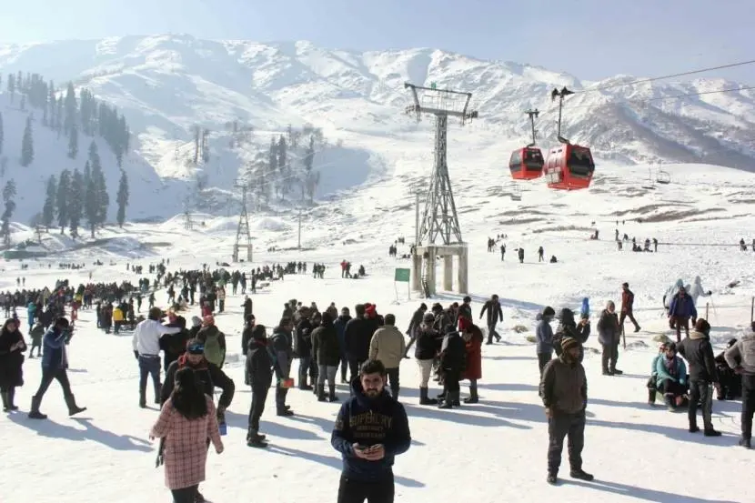

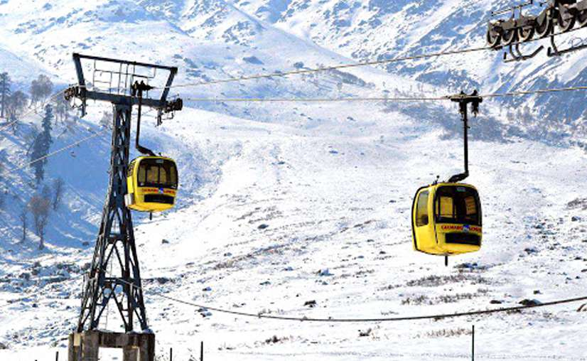

CHANDANWARI:- Chandanwari is a place in Kashmir, India, known for its scenic beauty and as the starting point for the annual Amarnath Yatra pilgrimage. It's a popular spot for tourists and pilgrims alike, offering breathtaking views of the surrounding mountains and landscapes

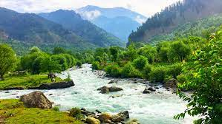

the name "Chandanwari" translates to "Sandalwood place" in English. Legend has it that the area was once abundant in sandalwood trees, hence the name.

Over time, Chandanwari became significant for its role as the starting point of the annual Amarnath Yatra pilgrimage. Every year, thousands of devotees embark on this sacred journey to visit the holy Amarnath Cave, where an ice stalagmite forms naturally and is believed to represent Lord Shiva.

Apart from its religious importance, Chandanwari has also become a popular tourist destination due to its breathtaking natural beauty. With snow-capped mountains, lush valleys, and gushing streams, it offers visitors a serene and picturesque retreat amidst nature's splendor.

Today, Chandanwari continues to attract pilgrims, tourists, and nature enthusiasts alike, serving as a gateway to both spiritual fulfillment and serene natural landscapes in the heart of Kashmir.

BETAAB VALLEY: Betaab valley is indeed located in the kashmir region of India, , is a picturesque destination known for its lush greenery, crystal-clear streams, and stunning views of the surrounding mountains. It gained fame after the Bollywood movie "Betaab" was filmed there in the 1980s, hence its name. The valley offers opportunities for trekking, picnics, and enjoying nature's beauty

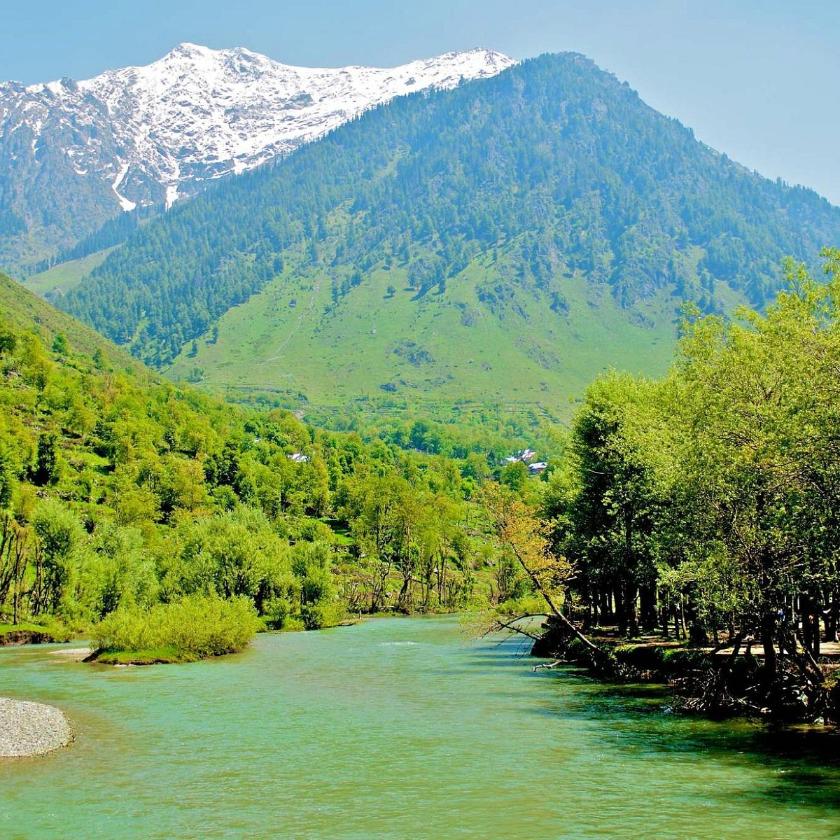

Betaab valley is a beautiful destination with a rich history with lush greenery, meandering rivers, and majestic mountains surrounding it. The valley has been inhabited for centuries, with indigenous communities living off its fertile lands and serene surroundings. Over time, it has become a popular tourist spot, attracting visitors from all over the world who come to admire its scenic landscapes and soak in its tranquil ambiance.

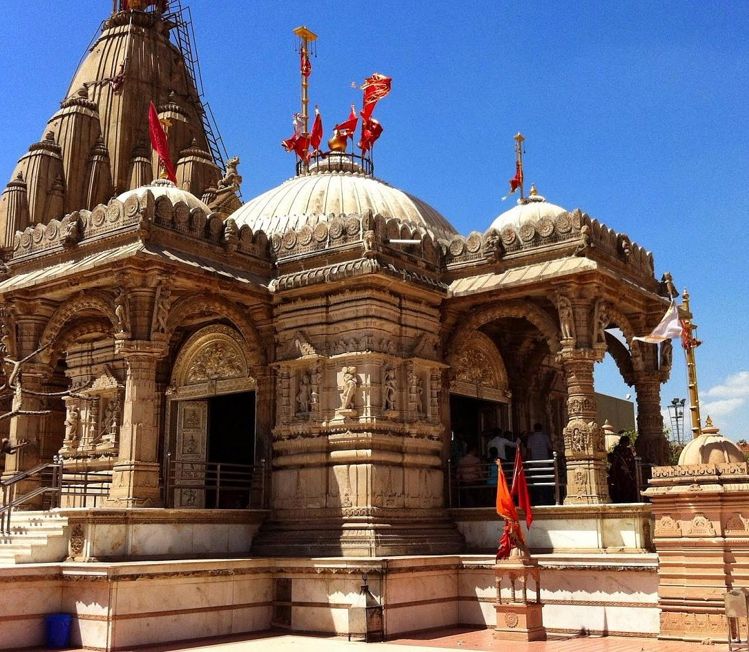SHANKARACHARYA TEMPLE: The Shankaracharya Temple, also known as the Jyeshteshwara temple, is situated on top of Shankaracharya Hill in Srinagar, Kashmir. It is dedicated to Lord Shiva and is one of the oldest temples in the region, believed to have been built in the 6th century AD by Adi Shankaracharya. The temple offers panoramic views of Srinagar city and the surrounding mountains, making it a significant pilgrimage site and tourist attraction.

The Shankaracharya Temple in Kashmir is really old, like from around 6th century AD. It was built by a famous philosopher and saint called Adi Shankaracharya. He dedicated the temple to Lord Shiva. This temple sits atop a hill called Shankaracharya Hill in Srinagar. People visit it for both religious reasons and to enjoy the beautiful views of Srinagar and the mountains around it.

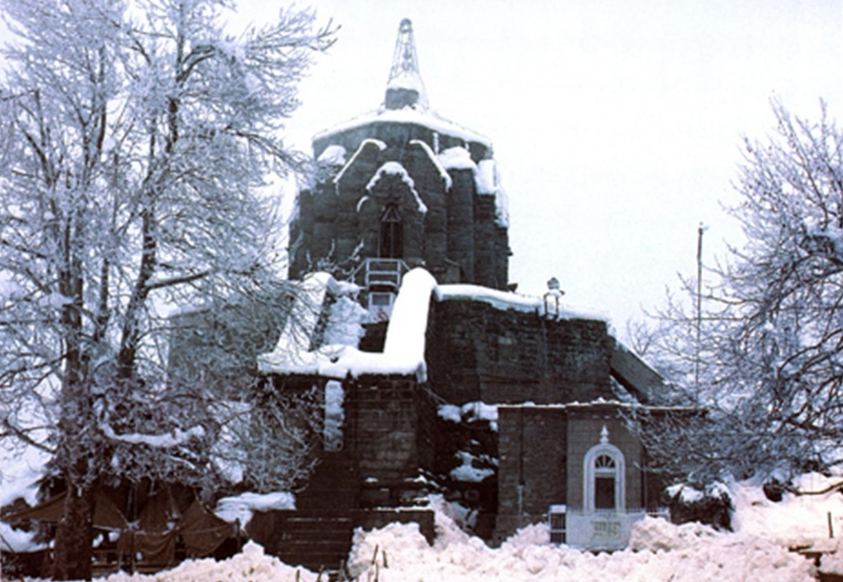

PARI MAHAL: Pari Mahal, located in Srinagar, Kashmir, is a historic garden built during the Mughal era. It's known for its terraced gardens, beautiful architecture, and panoramic views of the surrounding mountains and Dal Lake. It was once a Buddhist monastery before being converted into a pleasure garden by Dara Shikoh, the Mughal prince and scholar. Today, it's a popular tourist attraction, offering visitors a glimpse into Kashmir's rich cultural heritage and stunning natural beauty.

Pari Mahal in Kashmir has a fascinating history. Originally, it was a Buddhist monastery, where monks lived and prayed. Then, during the Mughal period, a prince named Dara Shikoh transformed it into a beautiful garden and palace. He built terraced gardens and lovely buildings, creating a place for relaxation and enjoyment. Over time, Pari Mahal became a symbol of Kashmir's rich heritage and attracted visitors from far and wide. Today, it stands as a testament to the region's history and beauty, offering stunning views of the mountains and Dal Lake

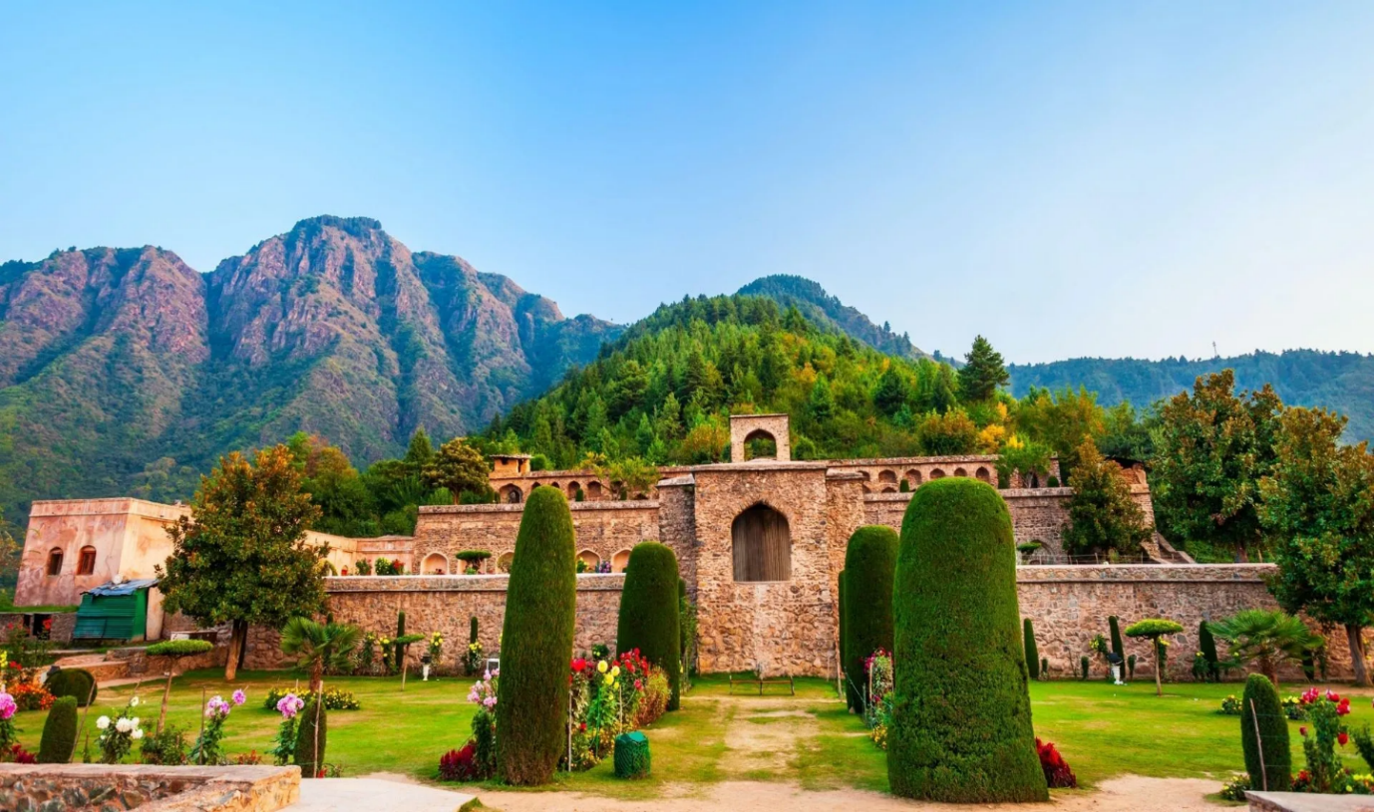

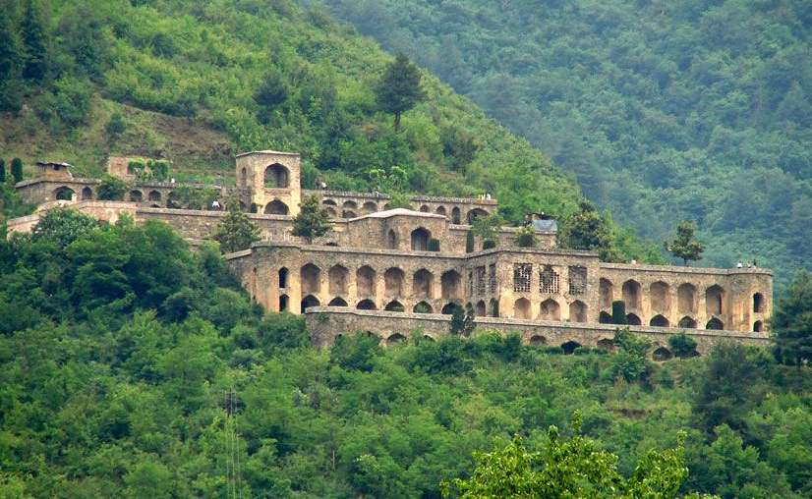

DAL LAKE: Dal Lake is a beautiful lake nestled in the heart of Srinagar, Kashmir. Its history dates back centuries, with the lake being formed by natural processes like the melting of glaciers and the flow of rivers. Over time, it became a vital part of Kashmir's culture and economy, serving as a source of water for irrigation, fishing, and transportation. The Mughal emperors recognized its beauty and built gardens and pavilions around its shores. Today, Dal Lake remains a cherished symbol of Kashmir's natural beauty and continues to enchant visitors from around the world

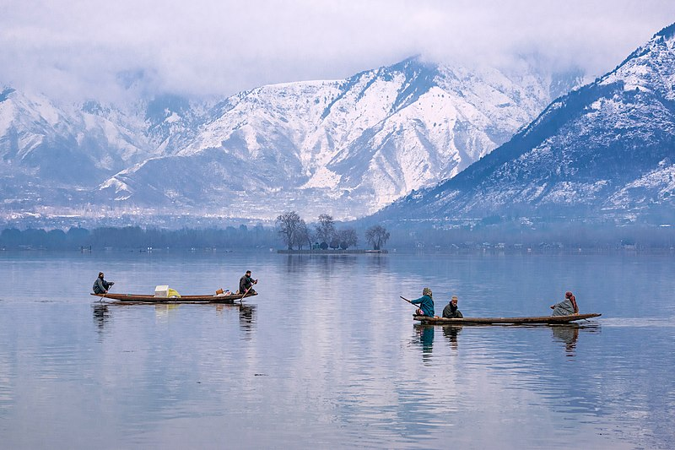Dal Lake is a picturesque lake in Srinagar, Kashmir, known for its stunning beauty and serene surroundings. It's famous for its houseboats, shikaras (traditional Kashmiri wooden boats), and floating gardens

# CONCLUSION

Kashmir is a region located in the northern part of the Indian subcontinent. It has been a longstanding source of conflict between India and Pakistan.

Both countries claim Kashmir in its entirety but control only parts of it.The dispute dates back to the partition of British India in 1947.Multiple wars and ongoing tensions have resulted in a heavily militarized region.

Efforts to resolve the issue through diplomacy and peace talks have been largely unsuccessful.

The Kashmir conflict remains one of the most enduring and volatile disputes in the world.

# REFERENCES

<http://www.getyourguide.com/>

<http://www.makemytrip.com/>

<https://wikitravel.org/en/Kashmir>